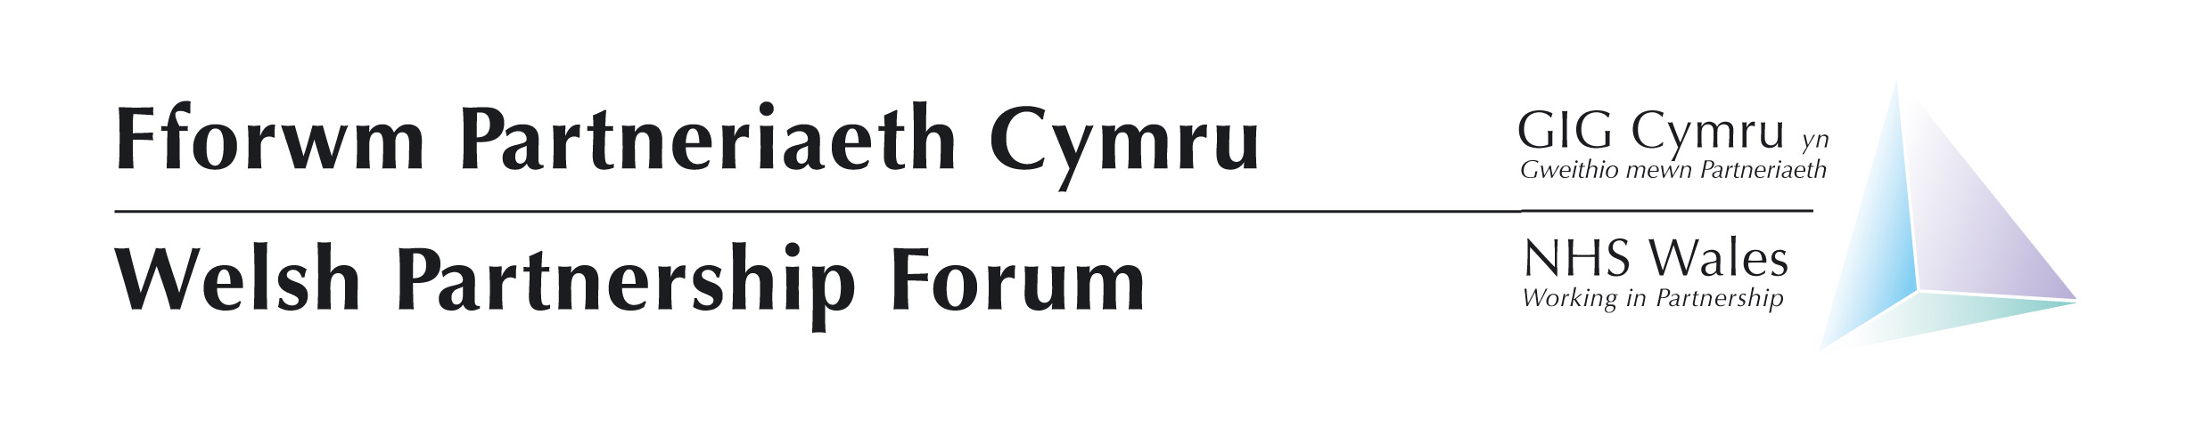

Business Committee
Thursday 8th June 2023
Unite The Union, 1 Cathedral Rd, Cardiff CF11 9SD
14:00-16:00 Suites 1-3 Main Meeting Room

(13:00-14:00 – Staff side pre-meeting - Suites 1-3 Main Meeting Room)
(13:00-14:00 Employers and Welsh Government pre-meeting – Training Room 1)
(
AGENDA

 | Agenda Item | Lead |  | Style of Report | Doc Number
Welcome and Apologies
 | Chair | Nicky Hughes | Verbal
Notes and actions of previous meeting
2. | Agree the notes of the meeting held 9th February and review progress on the actions on the action log | Chair | Paper |  | 01
Items for Decision
3. | Recruitment and Retention Business Case – Velindre NHS Trust | Management - Sue Price | Paper |  | 02a, 02b, 02c
4. | Policy Schedule, Update and Proposed Amendments to Policy Development and Review Protocol | NHS Wales Employers - Andrew Davies | Paper |  | 03
5. | Covid19 Sickness Transition Arrangements | NHS Wales Employers - Andrew Davies | Paper |  | 04
Strategic – Discussion
6. | Privatisation of NHS Services –  Confirmation of request for Provision of a Record of Externally Core Services | Chair/Welsh Government | Verbal
7. | Staff Welfare Project –  Update and next steps | Welsh Government - Martin Mansfield | Paper |  | 05a, 05b
8. | Update on Pay Deal Awards 2022/2023, non-pay element | Welsh Government | Verbal
Full Welsh Partnership Forum
9. | Welsh Partnership Forum Agenda | Chair | Verbal
10. | WPF Workplan  - Outcomes from WPF Workshop 17th November  - WPF forward look 2023 | NHS Wales Employers | Verbal
For Information & Recording
11. | Asbestos NHS Estates | Trade Union Partners - Nicky Hughes | Paper |  | 06
12. | New JD Template and Guidance | NHS Wales Employers | Paper |  | 07
13. | Feedback From Terms and Conditions Business Committee | NHS Wales Employers | Verbal
14. | Feedback from Medical and Dental Business Group | NHS Wales Employers | Verbal
Any other business
15. | To be notified in advance | Nicky Hughes | Verbal

Next meeting dates of the Business Committee
27th October 2023

